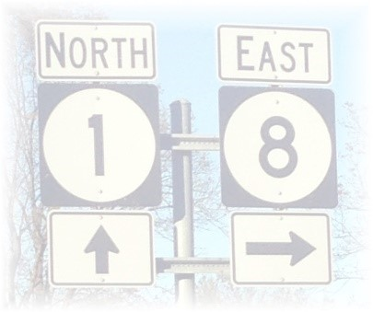

LEVEE BEATS & EATS AT ROSEDALE
DOWNTOWN ROSEDALE, MISSISSIPPI
SATURDAY, NOVEMBER 6, 2021
10:00 A.M. – 6:00 P.M.

Rules & Information for Arts & Crafts Vendors
All spaces subject to first paid/first served basis

- Payment is due when application is received, otherwise, vendor spots cannot be guaranteed.

- No electricity is provided. Vendors may use a generator. But are not allowed to use loud noise generators (max 65 DBA at 100% load).

- Vendors must furnish tables, chairs, tents, etc., should they want them. This is an outdoor festival! Be prepared for any weather condition – tents or other coverings are recommended. Your assigned space is final.

- The Festival Committee will select Arts/Crafts vendors based on the following:
- Variety/Type/Quality of item(s) sold
- Number of applications received
- Date completed application, including payment, is received.
We reserve the right to select the final offerings per vendor to ensure all
vendors to have an opportunity to have a successful day, thus less duplication.

- Arts/Crafts vendors are not allowed to sell alcoholic beverages.

- Registration and check-in is 7:30 a.m. – 9:00 a.m., NO LATER at the gazebo in Frankie Lawler Park at the festival entrance on Court Street. YOU MUST CHECK-IN BEFORE SETUP. Tent Number badges must be visible at all times during the festival.

- All booths, tents, etc., must be set up by 9:30 a.m. Saturday morning. Vendors assume full responsibility for displays, sales and care of their items. Vendor space must be left clean of any trash. Booths/tents/trailers are parked along the street. For safety purposes, you must leave your booth/tent/trailer in place until 5:00 PM. Leaving early will result in being removed from future vendor lists.

- Sales tax of 7% must be collected on all sales. Envelopes will be furished at check-in. Staff will pick up tax envelopes by 5 p.m. This is mandatory. Tax numbers will not be accepted.

- All applications are subject to approval of the Festival Committee. The committee reserves the right to reject an application at their sole discretion, and/or for the overall benefit of the festival. You will be notified of acceptance/rejection in a timely manner.

- Deadline to receive applications is 5:00 p.m. Friday, October 29, 2021.

- A $25.00 service charge will be deducted from any refunds requested on or before Friday, October 29, 2021. There will be NO refunds issued after the deadline date.

- The Levee Beats & Eats at Rosedale is a family event. You will be expected to conduct yourself in an appropriate manner and comply with all the rules, regulations and laws of the Town of Rosedale, Mississippi. Levee Beats & Eats at Rosedale, through the festival committee and/or authorized representative, reserves the right to terminate the operation of the vendor at any time during the festival for any of the following reasons: Professional manner is not maintained by the vendor or his/her employees, Vendor and/or employee commits any act detrimental to the purpose of the festival, Vendor and/or employee fails to cooperate with event management, Vendor and/or employee sells any product not listed on the approved list and/or Vendor and/or employee sells food or beverages not otherwise on approved on product list.

- Arts/Crafts Vendors understand that this festival is an outdoor event vulnerable to weather. Vendors understand that fees are non-refundable due to acts of God, inclement weather, dangerous conditions, acts or threats of terrorism, natural disasters, or war.

- No unauthorized vendors and solicitations allowed. Violators or anyone who fails to abide by the festival rules that are set forth will be removed from the festival.

- In the event of a pandemic order to shutdown events, all fees will be refunded.

Friends of Rosedale – P.O. Box 265 – Rosedale, MS 38769
www.friendsofrosedale.com

