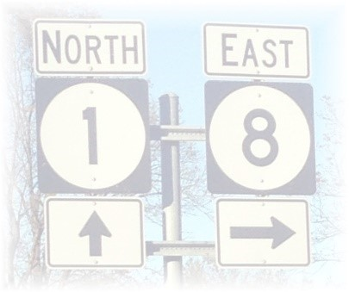

LEVEE BEATS & EATS AT ROSEDALE
DOWNTOWN ROSEDALE, MISSISSIPPI
SATURDAY, NOVEMBER 6, 2021
10:00 A.M. – 6:00 P.M.

FOOD VENDOR APPLICATION

Vendor/Business Name ______________________________________________________________________

Contact Name _____________________________________________________________________________

Address__________________________ City____________________ State __________ Zip_______________

Phone____________________________________ Email___________________________________________

*** ALL COMMUNICATIONS REGARDING THE FESTIVAL WILL OCCUR VIA EMAIL***

savingrosedale@gmail.com

Please include a complete detail listing of the items you will be selling:

Please complete the payment section below. All 10 x 20 food vendor spaces are $125.00. If you require more than a 10 x 20 space, please contact beforehand regarding pricing.

# of vendor spaces needed: __________ x $125.00 TOTAL AMOUNT DUE $_________

Method of Payment: Please make checks payable to Friends of Rosedale and remit payment along with completed application to:

Friends of Rosedale
ATTN: Levee Beats & Eats
P.O. Box 265
Rosedale, MS 38769

I have been provided a copy of the rules and regulations associated with being a vendor for Levee Beats and Eats at Rosedale and I agree to abide by them.

Signature:____________________________________________ Date:________________________

Friends of Rosedale – P.O. Box 265 – Rosedale, MS 38769
www.friendsofrosedale.com

