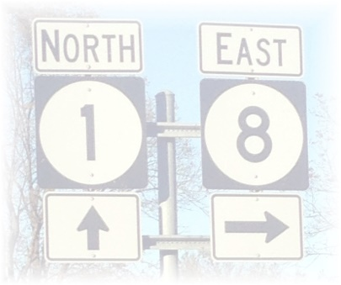

LEVEE BEATS & EATS AT ROSEDALE
DOWNTOWN ROSEDALE, MISSISSIPPI
SATURDAY, NOVEMBER 2, 2019
10:00 A.M. – 7:00 P.M.

ARTS & CRAFTS VENDOR APPLICATION

Vendor/Business Name __________________________________________________________________

Contact Name _________________________________________________________________________

Address__________________________ City____________________ State _________Zip____________

Phone_____________________________ Email___________________________________________

*** ALL COMMUNICATIONS REGARDING THE FESTIVAL WILL OCCUR VIA EMAIL***

savingrosedale@gmail.com

Vendor Category: (Please choose one that best describes your product)
______Arts/Crafts ______Reseller ______ Other Vendor

Please include a complete detailed listing of the items you will be selling.

Please complete the payment section below. All 10 x 10 arts/crafts vendor spaces are $50.00. If you require more than one 10 x 10 space, please contact beforehand about pricing.

# of vendor spaces needed: __________ x $50.00 TOTAL AMOUNT DUE $_________

Method of Payment: Please make checks payable to Friends of Rosedale and remit payment along with completed application to:
Friends of Rosedale
ATTN: Levee Beats & Eats
P.O. Box 265
Rosedale, MS 38769

I have been provided a copy of the rules and regulations associated with being a vendor for Levee Beats and Eats at Rosedale and I agree to abide by them.

Signature: ____________________________________________ Date: _________________

Friends of Rosedale – P.O. Box 265 – Rosedale, MS 38769 – savingrosedale@gmail.com
www.friendsofrosedale.com

