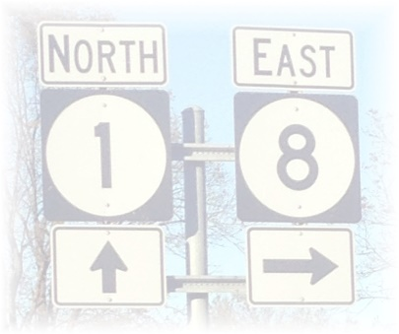

LEVEE BEATS & EATS AT ROSEDALE
DOWNTOWN ROSEDALE, MISSISSIPPI
SATURDAY, NOVEMBER 5, 2022
10:00 A.M. – 6:00 P.M.

ARTS & CRAFTS VENDOR APPLICATION

Vendor/Business Name _________________________________________________________________

Contact Name ________________________________________________________________________

Address______________________________City/State_________________________Zip____________

Phone____________________________ Email______________________________________________

Vendor Category: (Please choose one that best describes your product)
______Arts/Crafts ______Reseller ______Other Vendor

Please include a complete detailed listing of the items you will be selling.

Please complete the payment section below. All 10 x 10 arts/crafts vendor spaces are $50.00.

# of vendor spaces needed: __________ x $50.00 TOTAL AMOUNT DUE $_________

Method of Payment: Please make checks payable to Friends of Rosedale and remit payment along with completed application to:
Friends of Rosedale
ATTN: Levee Beats & Eats
P.O. Box 265
Rosedale, MS 38769

I have been provided a copy of the rules and regulations associated with being a vendor for Levee Beats and Eats at Rosedale and I agree to abide by them.

Signature:____________________________________________ Date:___________

Friends of Rosedale – P.O. Box 265 – Rosedale, MS 38769 – savingrosedale@gmail.com
www.friendsofrosedale.com

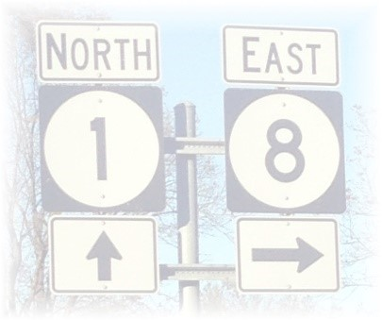

LEVEE BEATS & EATS AT ROSEDALE
DOWNTOWN ROSEDALE, MISSISSIPPI
SATURDAY, NOVEMBER 5, 2022
10:00 A.M. – 6:00 P.M.

Rules & Information for Arts & Crafts Vendors
All spaces subject to first paid/first served basis

- Payment is due when application is received, otherwise, vendor spots cannot be guaranteed.

- No electricity is provided. Vendors may use a generator. But are not allowed to use loud noise generators (max 65 DBA at 100% load).

- Vendors must furnish tables, chairs, tents, etc., should they want them. This is an outdoor festival! Be prepared for any weather condition – tents or other coverings are recommended. Your assigned space is final.

- The Festival Committee will select Arts/Crafts vendors based on the following:
- Variety/Type/Quality of item(s) sold
- Number of applications received
- Date completed application, including payment, is received.
We reserve the right to select the final offerings per vendor to ensure all
vendors to have an opportunity to have a successful day, thus less duplication.

- Arts/Crafts vendors are not allowed to sell alcoholic beverages.

- Registration and check-in is 7:30 a.m. – 9:00 a.m. at the gazebo in Frankie Lawler Park at the festival entrance on Court Street. YOU MUST CHECK-IN BEFORE SETUP. Tent Number badges must be visible at all times during the festival.

- All booths, tents, etc., must be set up by 9:30 a.m. Saturday morning and ready when the Festival opens at 10:00 a.m. ALL VEHICLES MUST BE OUT OF THE VENDOR AREA BY 9:30 a.m.
NO VEHICLES WILL BE ALLOWED IN THE VENDOR AREA UNTIL THE FESTIVAL IS OVER AT 6:00 p.m. THIS WILL BE STRICKLY ENFORCED. Vendors assume full responsibility for displays, sales and care of their items. Vendor space must be left clean of any trash. You must remain in your assigned space until at least 5:00 p.m. We strongly encourage you to stay until the festival is over at 6:00 p.m. Leaving prior to 5:00 p.m. will result in not being invited back to participate in future Levee Beats & Eats festivals.

- Sales tax of 7% must be collected on all sales. Envelopes will be disbursed at check-in. Vendors my drop the tax envelops off at the Levee Beats & Eats t-shirt tent at the end of the day. This is mandatory. Tax numbers will not be accepted.

- All applications are subject to approval of the Festival Committee. The committee reserves the right to reject an application at their sole discretion, and/or for the overall benefit of the festival. You will be notified of acceptance/rejection in a timely manner.

- Deadline to receive applications is 5:00 p.m. Monday, October 24, 2022.

- A $25.00 service charge will be deducted from any refunds requested on or before Monday, October 24, 2022. There will be NO refunds issued after the deadline date.

- The Levee Beats & Eats at Rosedale is a family event. You will be expected to conduct yourself in an appropriate manner and comply with all the rules, regulations and laws of the Town of Rosedale, Mississippi. Levee Beats & Eats at Rosedale, through the festival committee and/or authorized representative, reserves the right to terminate the operation of the vendor at any time during the festival for any of the following reasons: Professional manner is not maintained by the vendor or his/her employees, Vendor and/or employee commits any act detrimental to the purpose of the festival, Vendor and/or employee fails to cooperate with event management, Vendor and/or employee sells any product not listed on the approved list and/or Vendor and/or employee sells food or beverages not otherwise on approved on product list.

- Arts/Crafts Vendors understand that this festival is an outdoor event vulnerable to weather. Vendors understand that fees are non-refundable due to acts of God, inclement weather, dangerous conditions, acts or threats of terrorism, natural disasters, or war.

- No unauthorized vendors and solicitations allowed. Violators or anyone who fails to abide by the festival rules that are set forth will be removed from the festival.

For additional information about Arts & Crafts vendors contact:
Debbie Leftwich at 251.604.5651
Anne Martin Vetrano at 662.379.6867

